It is vocabulary that allows you to annotate and validate the JSON documents.

Basically it describes the data format for JSON. JSON supports different data types, for example, the Boolean, String, it can be a JSON object or JSON array. So the JSON schema describes the data types for JSON fields. It confirms that the data type of a particular field is as expected.

In other words JSON schema provides the human and machine readable documentation for the JSON. And it can be used to validate the data for automated testing.

We can use the online tools to convert the JSON to JSON Schema: https://transform.tools/json-to-json-schema

Example:

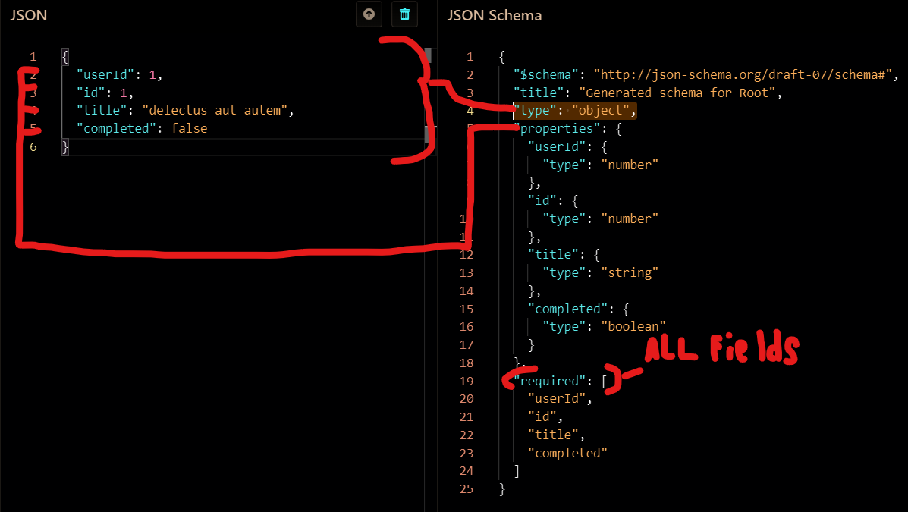

Type - it recognizes the type of the JSON, is object or an array

In order to work with JSON schema in a Rest Assured we need to add the dependency, marked with arrow. If we don't

use the Rest Assured the dependency should be different. 